Spare Parts Puppet Theatre’s
Splat!
By Sally Richardson
Education Resource
Primary
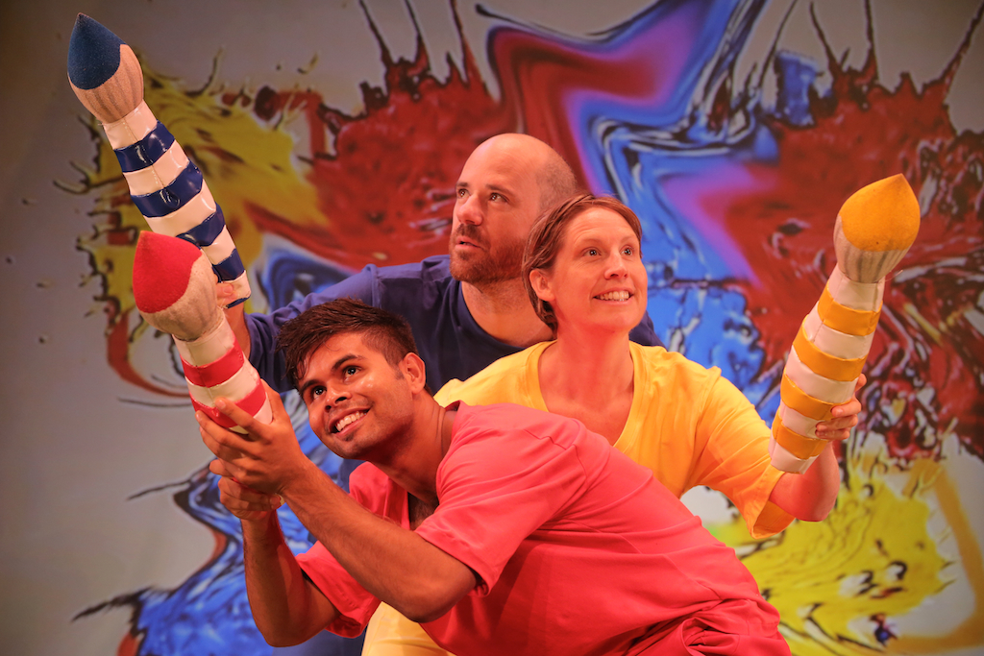

Resources:
- Excursion Plan
- Theatre Etiquette
- About the Show
- Discussion Questions
- Classroom Activities

Excursion Plan

Contact: Operations Officer, Georgina Cramond
Phone: 08 9335 5044
Email: admin@sppt.asn.au
Website: www.sppt.asn.au

Environment:
- Venue: Spare Parts Puppet Theatre, 1 Short Street Fremantle. The theatre is located within Pioneer Park.
- Access to the building can be obtained from the main entrance on Short Street, facing Market Street.
- Wheelchair access is available. Should you have students that require wheelchair access please contact us prior to your excursion on 08 9335 5044.
- Within our foyer we boast a collection of puppets from our 39 year history. We encourage you and your students to explore the foyer and the puppets before/after the show.
- Our theatre is located within Pioneer Park. You’re welcome to enjoy lunch or recess in the park before/after the show.

Transport:
- We are located across the road from the Fremantle train station. For public transport options please contact
- http://www.transperth.wa.gov.au/
- If travelling by private bus, students can be dropped off at the main entrance of the theatre (Short Street) or on Phillimore Street.

Insurance and Evacuation Plans
- Public Liability Insurance Certificate
- Evacuation Plan

Briefing Students and Supervisors
- We encourage teachers to brief their students and adult helpers on suitable theatre etiquette prior to attending the show. See ‘Theatre Etiquette’ for tips.
- Please arrive at least 15 minutes prior to the show start time.
- Eating, drinking and photography is not permitted within the theatre space

Theatre Etiquette

There are two groups of people at the theatre, the audience and the performers. Each group has a certain role to play and has certain behavior expected of them. Before you attend the show you may like to:

- Discuss what audience and performer mean
- Talk about the behavior expected from the audience and from the performers.
Pre-Show Activity

Give students an A3 piece of paper, and draw three circles to form a Venn diagram. In one circle write “audience member” and in the other “performer”, where the circle overlaps is “both”.

Call out various behaviours (ideas listed below) and ask students to put the behavior either in the “Audience” or the “Performer” circle on their paper to represent good theatre etiquette. They may like to suggest some ideas of their own!

Hint: Some behaviours will be appropriate for both Audience and Performer which means it goes in the section where the circles overlap. This is a great opportunity for discussion if students don’t agree on where the behavior should go on the Venn diagram.

- Does not chit chat
- Sits still
- Goes to the toilet before the show
- Is ready on time
- Faces the audience
- Keeps their eyes on the stage
- Is nice and quiet
- Doesn’t eat or drink during the show
- Claps at the end

About the Show:

Splat is a visual feast of art play, gymnastics, puppets and clowning. Our hero, Jo loves to draw, paint, and make things and wants to make friends. Through his art creating and play he expresses how he feels and how he sees his world. His mates, Dib & Dob, like doing everything together. They like making and creating things too, but not the same way as our hero. They don’t understand Jo, Jo is different.
Through playing, watching, making discoveries and finally sharing, they all learn to play together and so discover that each person experiences the world in a different way. Difference is not so scary after all.
Through art we can be who we want to be and go where we want to go. There really is no limit to the imagination!

“Play increases children’s willingness to develop
inter-personal relationships through shared endeavours”
(Boyer 1998)
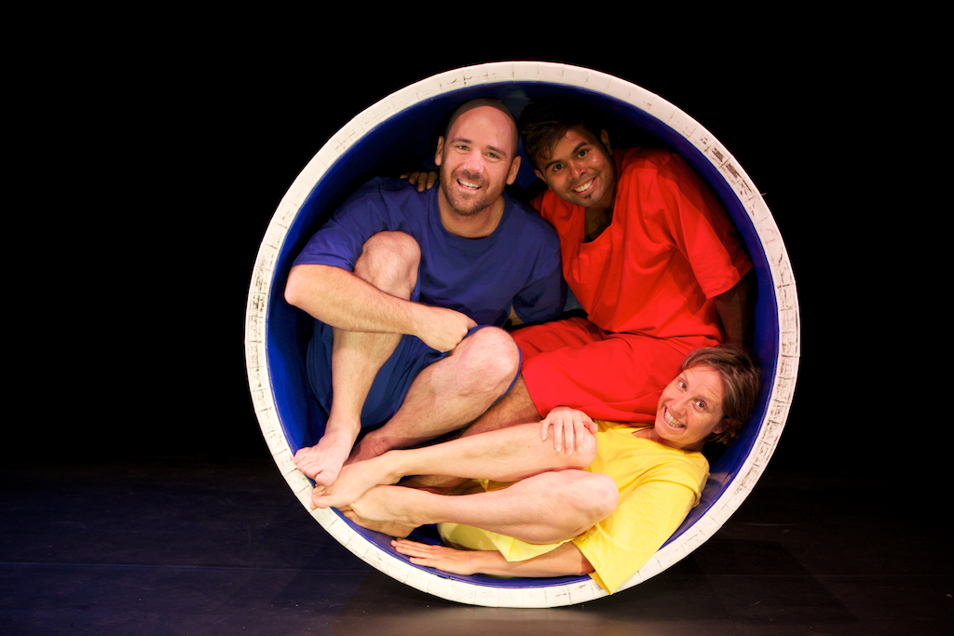

Discussion Questions

Pre show Questions

Splat is a show that will be performed on a stage at a theatre. Have you been to a theatre before? What do you think it looks like?

What kind of things will we see at the theatre? Will they be the same things as a classroom or your home?

Who works at the theatre? What is their job? What do they have to do?

How would you define friendship? Are all friendships the same or do they come in various shapes and sizes?

How will we need to behave at the theatre? What kind of behavior will be appropriate and what won’t?

What happens at the end of the show? What do we have to do? What do the performers have to do?

How can we tell the performers we enjoyed the show and they did a good job?

Post Show Questions
[hints for teachers]

Was the show what you expected? Why?

How did you feel when you watched the show? What was it like being an audience member?

Splat is a non-verbal show. This means there is no script and no words are spoken in the show. However ‘communication’ happens in several ways. Discuss how the performers communicated the story and messages to the audience

There were lots of props on the stage, what did the performers use them for?
[The Blue Circle is calm and imaginative, the Red Square is energetic, and the leader of the pack and the Yellow Triangle is the clown of the group.]

How do you think Jo felt when he was left out of the games? How do you feel if you are left out?

How did the characters all learn to play together? What do you do when you want to join in a game?

What was the job/ role of the puppets?
[The puppetry in Splat revolves around Object Theatre. This style of puppetry also captures the imaginative way in which children play.]
INTERESTED IN THE CREATIVE PROCESS?

The creative team is composed of various artists who work together to create and develop the performance. The process of creating a show can take over a year and there are various stages of development, which are:
- Creative Development – where ideas for the show are workshopped
- Script developed
- Design for the show created
- Music composed
- Puppets and Set build
- Performers cast
- Rehearsal Period
- Show opens

NON-VERBAL COMMUNICATION

Subject Area: English - Language for interaction, Interacting with others

Discuss what non-verbal communication means. Showing how you can communicate using hand gestures, by pulling faces etc. (happy, sad, confused or hurt) and you can also make sound effects.

Ask students to think about what it would be like to watch the TV with no sound. Tell students
about the ‘olden days’ when families would sit around the radio and listen to stories with talking and sound effects, but no pictures. Encourage students to think about different forms of communication and how we interpret meaning. Storybooks are only one way to tell a story.

Activity:
- Create a story; it could be as simple as driving to the shops to buy an ice-cream.
- Split students into three groups.
- Ask one group of students to put sound effects to the story, i.e. the ‘putt putt putt’ of the car, the ‘ching ching’ of the cash register, the ‘slurp’ of eating the ice cream as it melts etc.
- Ask the second group of students to think of the actions involved with the story. Driving with the steering wheel and changing of gears, buying the ice-cream might be pointing to something and getting money out of a wallet and eating the ice-cream might involve students sticking their tongues out a lot.
- Join the sound effects and the actions together.
- Have the third group of students determine the story by watching the first two groups perform.
- Discuss how easy/hard it was for them to understand the story without words.

HOW MUSIC AFFECTS A MOOD

Suggest music available on YouTube
Teacher may choose any music/song that they wish.
- Robert Schumann’s Perfect Happiness http://www.youtube.com/watch?v=SYwyGbujboI
- Chopin’s Prelude in E Minor Op. 28 http://www.youtube.com/watch?v=X0IpJmg3EWc
- Mozart’s Piano Concerto No 17 in G (Major Key) https://www.youtube.com/watch?v=l0aBhRxA9HAs
- Mahler’s Symphony No 11.111, Funeral March http://www.youtube.com/watch?v=WVsLCzSK7Rs

1. Talk about how emotions can be explored through music. Children listen to Robert Schumann’s Perfect Happiness & Chopin’s Prelude in E Minor Op. 28.
Do not tell children the music pieces titles as it may influence their interpretations. Children call out emotions. Discuss relating to colours.

2. Listen to a section of Mozart’s Piano Concerto No 17 in G (Major Key). Children listen to the music and then draw pictures that they think matches the mood of the music.

3. Can repeat the process to Mahler’s Symphony No 11.111, Funeral March (see link above)

5. As a whole group discuss what was different in the two pieces of music

SPLAT PAINTING
Subject Area: Art and English

The performers in the show used paints to create texture, movement and colour within the show. Create your own splat paintings using the three primary colours from splat: red, blue and yellow. When the paintings are dry ask children to identify other colours they can see that have been created where the primary colours have mixed together.

Children should reflect on how colour and music can make them feel certain emotions. The shapes and lines they create in their artwork may reflect their feelings and their response to the show.

Discuss different types of lines and shapes and how they can portray different meaning (smooth, flowing lines vs sharp zig zagged lines).

Ask students to draw things based on a feeling choosing the colour to match:

- Ask students to draw an angry line
- Ask students to draw a calm line
- Ask students to draw a bossy shape
- Ask students to draw a patient shape

Compare geometric shapes with organic shapes and discuss the difference. Did most students use organic shapes to show calmness and patience? Did students use sharp geometric lines and shapes to show angry and bossiness? What colours were selected to express different emotions?

Acrobatics Obstacle Course

Subject Area: Physical Education

The performers engage in lots of gross motor body movements on stage, they twirl, roll, flip run and slide. They mimic the movements of young children as they play. With the children brainstorm a list of all the body movements they saw the performers make on stage.

Create an obstacle course in the playground that will allow the children to use the same movements, you could ask the students to draw a design of the obstacle course in small groups. Use mats, boards, cubes, hoops and any other equipment available that reflects the shapes from the stage props in Splat. Teachers of year 1- 3 may like to visit the pre-primary area and use their outdoor equipment.

Reflect on the movements the children were doing, and the equipment they used during this lesson, drawing comparisons from the performance of Splat. Remind students that all movements they saw in splat were planned and rehearsed lots of times prior to the performance. This is different to the context in which students are developing an obstacle course in one lesson at school.

BE A CRITIC

Subject Area: English – Expressing and developing ideas, responding to literature

By visiting the theatre and seeing performances, students are learning how to become critical audience members that can reflect on what they’ve seen, apply their own background knowledge and personal experiences to the story/show and draw their own conclusions.

Encourage students to put their thoughts and reactions down on paper by writing a review. This may include:
- How the show made them feel
- What it reminded them of (did it make you reflect on past experience you’ve had?)
- How students related to the characters
- What could be better?
- How did the set and performers express different messages? Did it work well?

The best part? All reviews can be emailed or posted to Spare Parts Puppet Theatre for the director of the show to read! admin@sppt.asn.asu / PO Box 897, Fremantle WA 6959.

